JAVA PROGRAM-9(18/10/2018)

1)Write a java program for the following given inheritance?
A

B
CODE:

class Bike
{
int Wheels=2;
int Breaks=2;
int Tank=1;
void bikeData()
{
System.out.println("No of wheels:"+Wheels);
System.out.println("No Breaks:"+Breaks);
System.out.println("No of Tank:"+Tank);
}
}

class Bullet extends Bike
{
int engine=2;
int seats=2;
void bulletData()
{
System.out.println("NO of engine:"+engine);
System.out.println("No of seats:"+seats);
System.out.println();
System.out.println();
System.out.println();

}
}

class TestSingle {

public static void main(String[] args) {
System.out.println("Bullet Properties");
System.out.println("................");
Bullet obj=new Bullet();
obj.bikeData();
obj.bulletData();

}

}

OUTPUT:

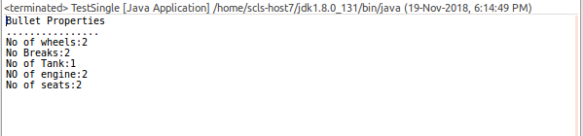

2) A

B

C

D

class bike1
{
int Wheels=2;
int Breaks=2;
int Tank=1;
void bikeData()
{
System.out.println("No of wheels:"+Wheels);
System.out.println("No Breaks:"+Breaks);
System.out.println("No of Tank:"+Tank);
}
}
class vespa1 extends Bike
{
int engine=1;
String colour="yellow";
void vespaData()
{
System.out.println("No of engine:"+engine);
System.out.println("No of colour:"+colour);

}
}

class Bullet1 extends Bike
{
int engine=2;
int seats=2;
void bulletData()
{
System.out.println("NO of engine:"+engine);
System.out.println("No of seats:"+seats);
}
}

class Classic extends Bullet1
{
int enginecc=3;
int seats=1;
void classicData()
{
System.out.println("NO of engine:"+enginecc);
System.out.println("No of seats:"+seats);
}
}

public class TestMulpl {

public static void main(String[] args) {

System.out.println("vespa1 Properties");
System.out.println("................");
vespa1 obj=new vespa1();
obj.bikeData();
obj.vespaData();

System.out.println();
System.out.println();

System.out.println("Bullet1 Properties");
System.out.println("................");
Bullet1 obj1=new Bullet1();
obj1.bikeData();
obj1.bulletData();

System.out.println();
System.out.println();

System.out.println("Classic Properties");
System.out.println("................");
Classic obj2=new Classic();
obj1.bikeData();
obj2.bulletData();
obj2.classicData();

}

}

OUTPUT:

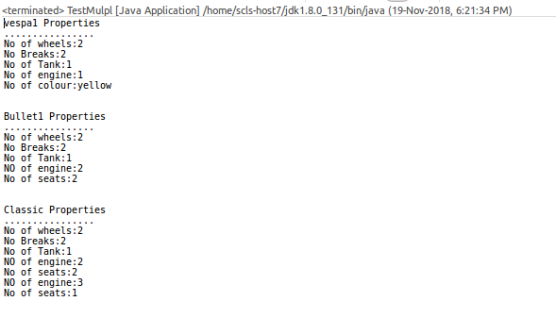

3) A

B C D

CODE:

class Car
{
int Wheels=4;
int Breaks=1;
int Tank=1;
void carData()
{
System.out.println("No of wheels:"+Wheels);
System.out.println("No Breaks:"+Breaks);
System.out.println("No of Tank:"+Tank);
}
}
class Skoda extends Car
{
String luxary="super";
int seats=4;
void skodaData()
{
System.out.println("NO of engine:"+luxary);
System.out.println("No of seats:+seats");

}
}

class Benz extends Car
{
String features="Exclent";
String couting="fabelous";
void BenzData()
{
System.out.println(" features:"+features);
System.out.println(" couting:"+couting);

}
}

class Audio extends Car
{
String s="good";
String d="super";
void AudioData()
{
System.out.println("demand:"+s);
System.out.println("comfortable:+d");

}
}

class TestHierarchial {

public static void main(String[] args) {

System.out.println("Skoda Properties");
System.out.println("................");
Skoda obj1=new Skoda();
obj1.carData();
obj1.skodaData();

System.out.println();
System.out.println();

System.out.println("Benz Properties");
System.out.println("................");
Benz obj2=new Benz();
obj2.carData();
obj2.BenzData();

System.out.println();
System.out.println();

System.out.println("Audio Properties");
System.out.println("................");
Audio obj3=new Audio();
obj3.carData();
obj3.AudioData();

}

}

OUTPUT:

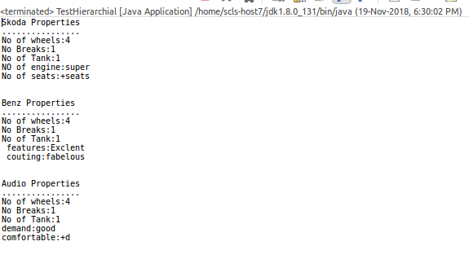

4) A

B C

D

CODE:

class bike1
{
int Wheels=2;
int Breaks=2;
int Tank=1;
void bikeData()
{
System.out.println("No of wheels:"+Wheels);
System.out.println("No Breaks:"+Breaks);
System.out.println("No of Tank:"+Tank);
}
}
class vespa1 extends Bike
{
int engine=1;
String colour="yellow";
void vespaData()
{
System.out.println("No of engine:"+engine);
System.out.println("No of colour:"+colour);

}
}

class Bullet1 extends Bike
{
int engine=2;
int seats=2;
void bulletData()
{
System.out.println("NO of engine:"+engine);
System.out.println("No of seats:"+seats);
}
}

class Classic extends Bullet1
{
int enginecc=3;
int seats=1;
void classicData()
{
System.out.println("NO of engine:"+enginecc);
System.out.println("No of seats:"+seats);
}
}

public class TestMulpl {

public static void main(String[] args) {

System.out.println("vespa1 Properties");
System.out.println("................");
vespa1 obj=new vespa1();
obj.bikeData();
obj.vespaData();

System.out.println();
System.out.println();

System.out.println("Bullet1 Properties");
System.out.println("................");
Bullet1 obj1=new Bullet1();
obj1.bikeData();
obj1.bulletData();

System.out.println();
System.out.println();

System.out.println("Classic Properties");
System.out.println("................");
Classic obj2=new Classic();
obj1.bikeData();
obj2.bulletData();
obj2.classicData();

}

}

OUTPUT:

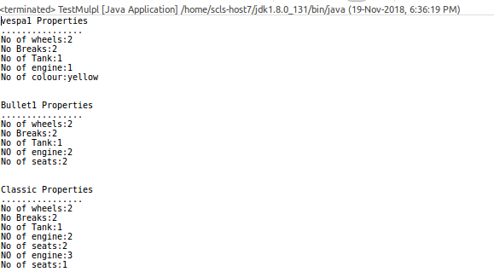

5)
A

B C D

E

F G

CODE:
class Father
{
int Houses=5;
int division=4;
int land=15;
int property=10909088;

void fatherData()
{
System.out.println("No of Houses:"+Houses);
System.out.println("No of Divsion:"+division);
System.out.println("No of lands:"+land);
System.out.println("Property prestne:"+property);

}
}
class Ravi extends Father
{
int money=324234;
String owned="unlimited";
int Houses=5;
void raviData()
{
System.out.println("The money earnes:"+money);
System.out.println("He owned property:"+owned);
System.out.println("NO of HOuses:"+Houses);
}
}

class Kishore extends Father
{
int money=4234;
String owned="limited";
int Houses=4;
void kishoreData()
{
System.out.println("The money earnes:"+money);
System.out.println("He owned property:"+owned);
System.out.println("NO of HOuses:"+Houses);
}
}

class Rakesh extends Father
{
int money=4234234;
String owned="limited";
int Houses=30;
void rakeshData()
{
System.out.println("The money earnes:"+money);
System.out.println("He owned property:"+owned);
System.out.println("NO of HOuses:"+Houses);
}
}

class Mother extends Kishore
{
int money=34;
String owned="limited";
int Houses=2;
void motherData()
{
System.out.println("The money earnes:"+money);
System.out.println("He owned property:"+owned);
System.out.println("NO of HOuses:"+Houses);
}
}

class Jay extends Mother
{
int money=300;
String owned="limited";
int Houses=89;
void jayData()
{
System.out.println("The money earnes:"+money);
System.out.println("He owned property:"+owned);
System.out.println("NO of HOuses:"+Houses);
}
}
class Vineeth extends Mother
{
int money=2300;
String owned="limited";
int Houses=79;
void vineethData()
{
System.out.println("The money earnes:"+money);
System.out.println("He owned property:"+owned);
System.out.println("NO of HOuses:"+Houses);
}
}

public class TestSmHr {

public static void main(String[] args) {

System.out.println("Print Ravi Property");
System.out.println("......................");
Ravi obj=new Ravi();
obj.fatherData();
obj.raviData();

System.out.println();
System.out.println();

System.out.println("Print Kishore Property");
System.out.println("......................");
Kishore obj1=new Kishore();
obj1.fatherData();
obj1.kishoreData();

System.out.println();
System.out.println();

System.out.println("Print Rakesh Property");
System.out.println("......................");
Rakesh obj2=new Rakesh();
obj2.fatherData();
obj2.rakeshData();

System.out.println();
System.out.println();

System.out.println("Print Mother Property");
System.out.println("......................");
Mother obj3=new Mother();
obj3.fatherData();
obj3.kishoreData();
obj3.motherData();

System.out.println();
System.out.println();

System.out.println("Print Jay Property");
System.out.println("......................");
Jay obj4=new Jay();
obj4.fatherData();
obj4.kishoreData();
obj4.motherData();
obj4.jayData();

System.out.println();
System.out.println();

System.out.println("Print Vineeth Property");
System.out.println("......................");
Vineeth obj5=new Vineeth();
obj5.fatherData();
obj5.kishoreData();
obj5.motherData();
obj5.vineethData();

System.out.println();
System.out.println();

}

}

OUTPUT:
